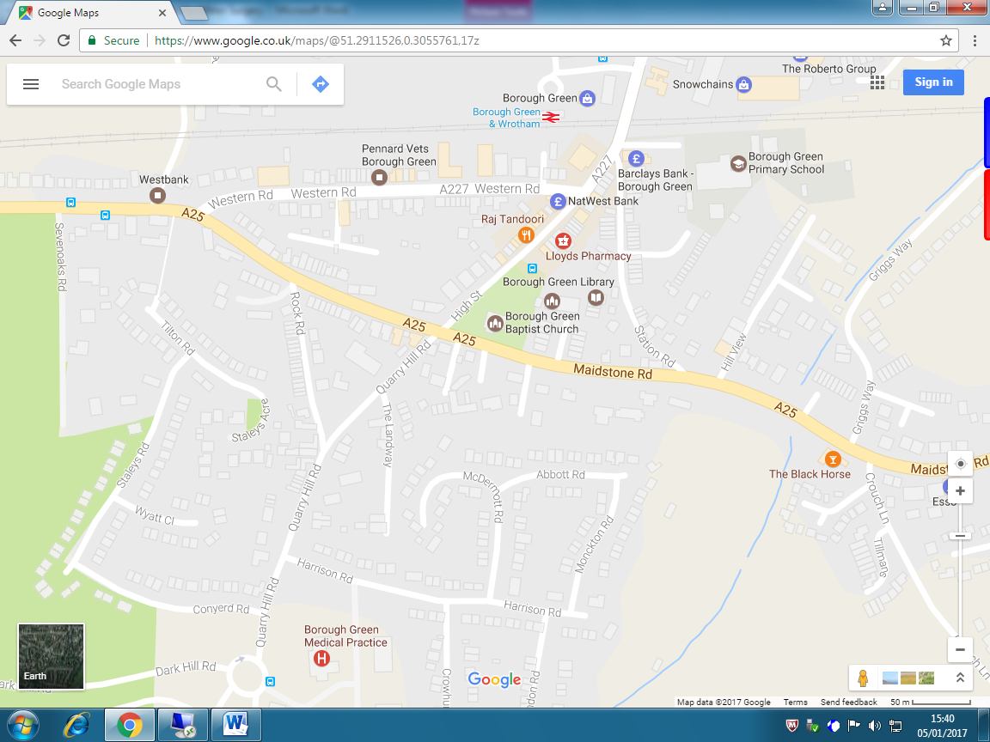

Borough Green Medical Practice Telephone: 01732 881293 or 01732 883161

Quarry Hill Road

Borough Green

Kent TN15 8RQ  Telephone: 01732 881293 or 01732 883161