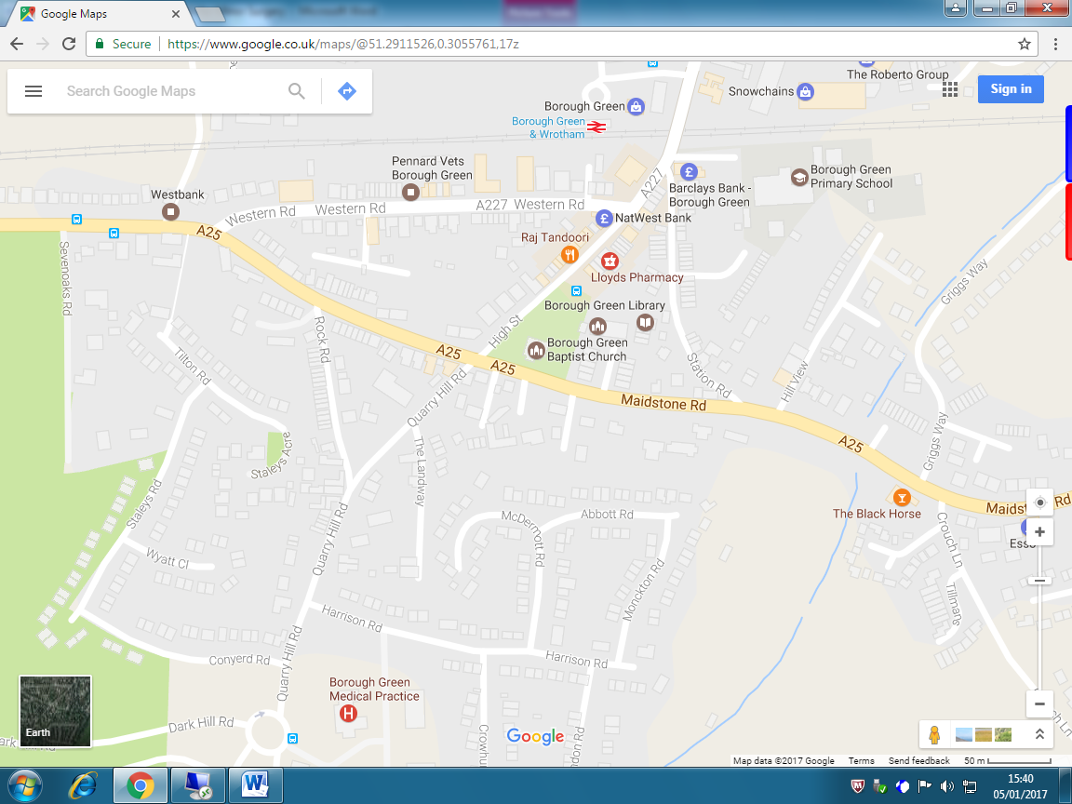
Borough Green Medical Practice Telephone: 01732 881293 or 01732 883161
Quarry Hill Road
Borough Green
Kent TN15 8RQ Telephone: 01732 881293 or 01732 883161

